PF LAB 4 TASKS

TASK 1:
#include<stdio.h>
main()
{
int age;
printf("enter your age: ");
scanf("%i" , &age);
if (age >= 18){
printf("you are eligible to vote");
}
else{
printf("you are not eligibe to vote");
}
}
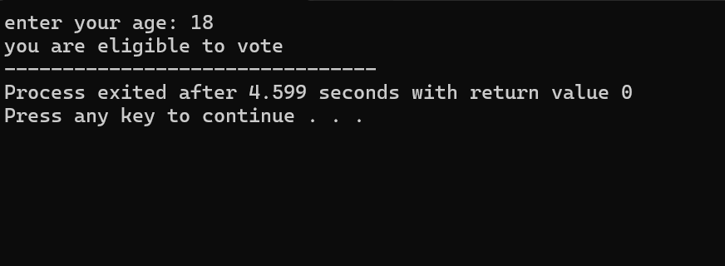

TASK 2:
#include<stdio.h>
main()
{
int number;
printf("enter a number: ");
scanf("%i", &number);
if (number%2==0){
printf("the number is even");
}
else{
printf("number is odd");
}

}
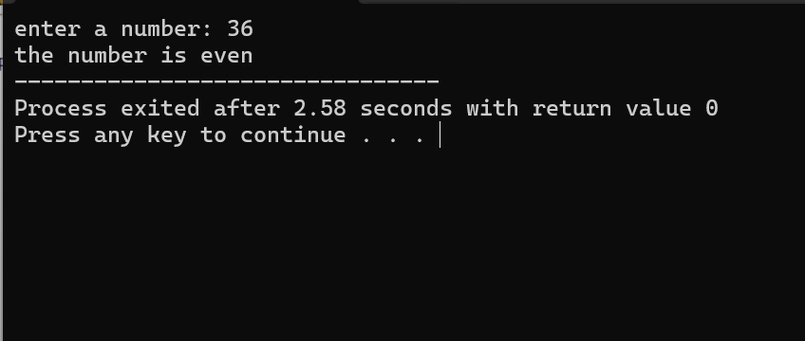

TASK 3:
#include<stdio.h>
main()
{
int num1;
int num2;
int num3;
printf("enter the first number: ");
scanf("%i" , &num1);
printf("enter the second number: ");
scanf("%i" , &num2);
printf("enter the third number: ");
scanf("%i" , &num3);
if ((num1 > num2) && (num1 > num3)){
printf("number 1 is greatest");
}
else if ((num2 > num1) && (num2 > num3)){
printf("number 2 is greatest");
}
else if((num3>num1) && (num3 > num2)){
printf("number 3 is greatest");
}
}
